Notes about DOM

Document Structure

Html Page

<!doctype html>

<html>

<head>

<title>My home page</title>

</head>

<body>

<h1>My home page</h1>

<p>Hello, I am Marijn and this is my home page.</p>

<p>I also wrote a book! Read it

<a href="http://eloquentjavascript.net">here</a>.</p>

</body>

</html>

This page has the following structure:

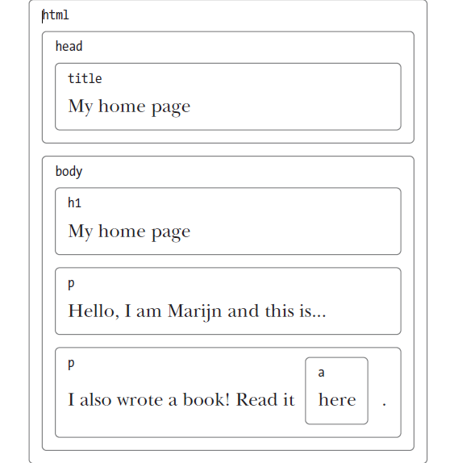

* The data structure the browser uses to represent the document follows this shape. For each box, there is an object, which we can interact with to find out things such as what HTML tag it represents and which boxes and text it contains. This representation is called the Document Object Model, or DOM for short.

Notes

* The global variable document gives us access to these objects.
* We call a data structure a tree when it has a branching structure, has no cycles (a node may not contain itself, directly or indirectly), and has a single, well-defined “root.” In the case of the DOM, document.documentElement serves as the root.
* In addition to representing recursive structures such as HTML documents or programs, they are often used to maintain sorted sets of data because elements can usually be found or inserted more efficiently in a sorted tree than in a sorted flat array.

Moving through the DOM

* DOM nodes contain a wealth links to other nearby nodes.

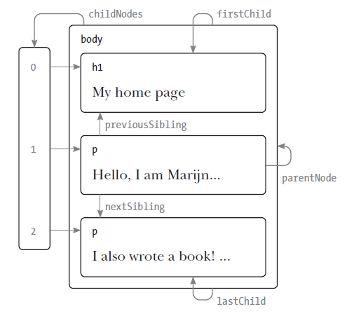

* Every node has a parentNode property that points to its containing node.
* Likewise, every element node (node type 1) has a childNodes property that points to an array like object holding its children.